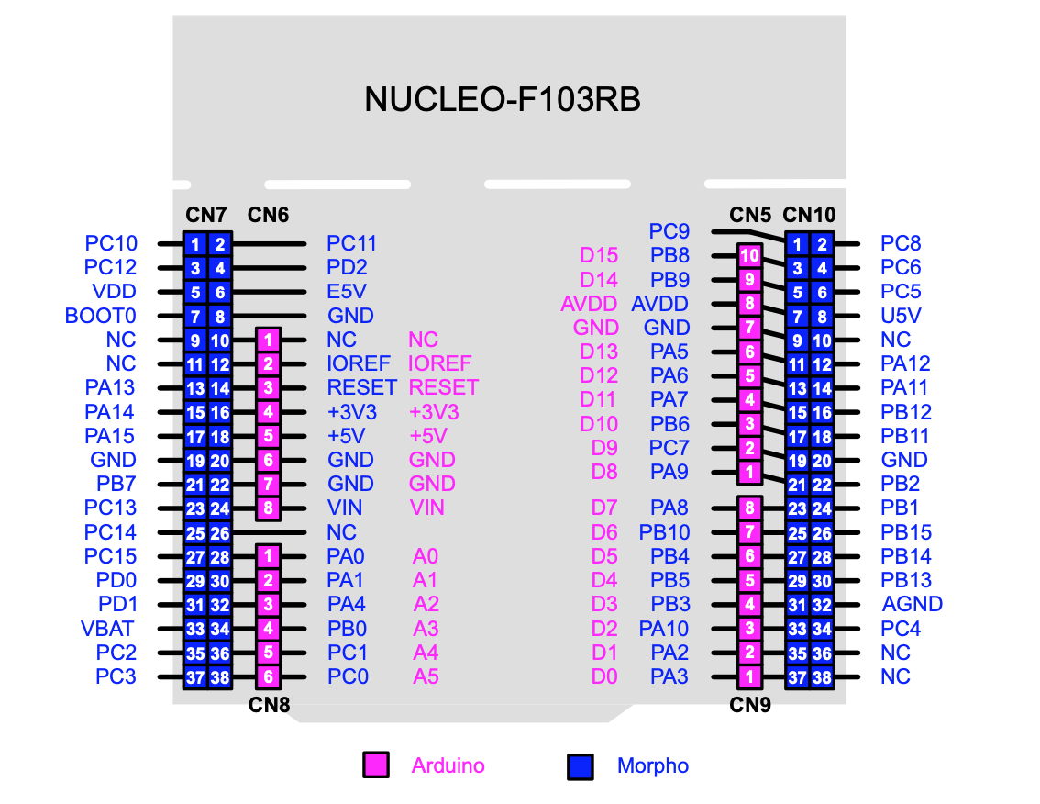

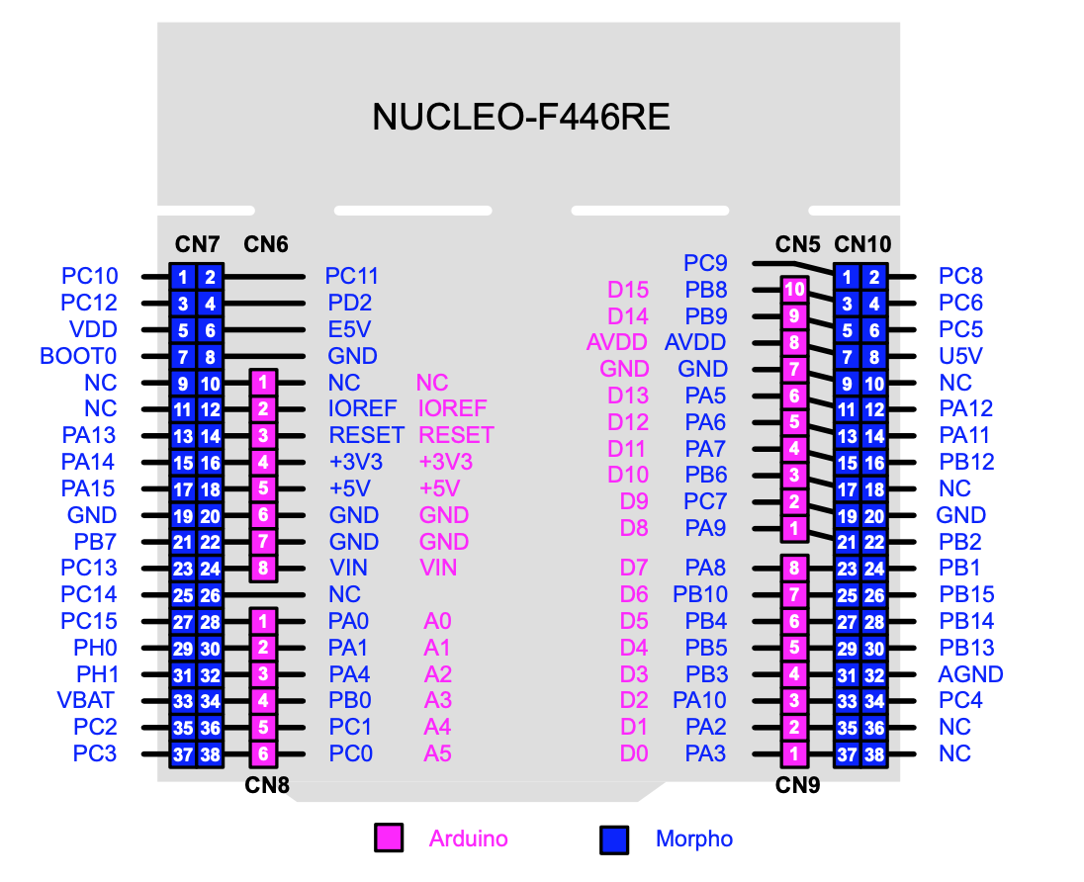

ENC 2 - Left

ENC 1 - Left

DIR - Left

ENC 2 - Right

PWM - Left

ENC 1 - Right

DIR - Right

PWM - Right

IMU Data Ready

I2C1-SCL IMU

I2C1-SDA IMU